Alamy

🔹 Definition
# Source: ScreenShots Source: Provided by: [Persons Table -> ID Column: 1, Name_En Column: Motasem Essam] -> Tool: [Lightshot Program] -> From [Site: https://www.alamy.com/] on [11/15/2025]
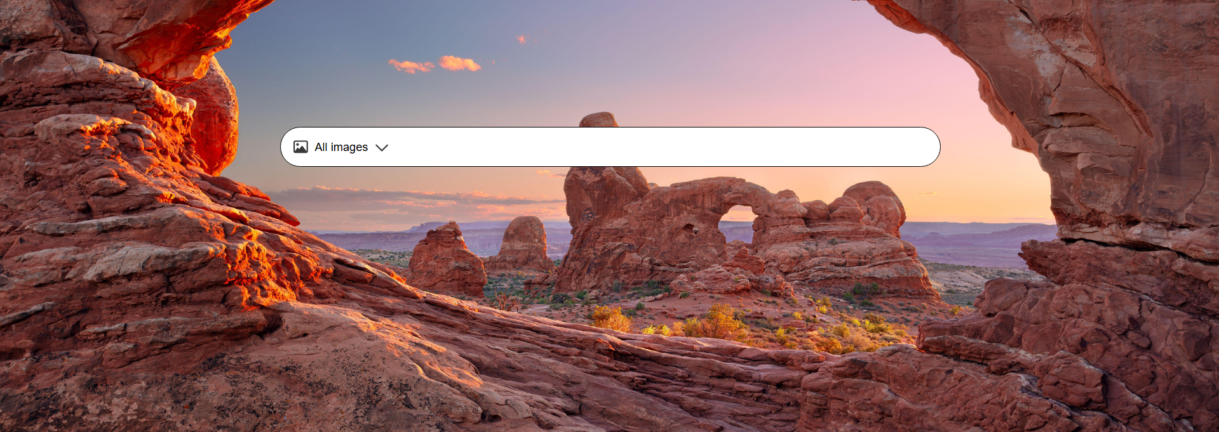
# Source: AI Source: Provided by: [Data Path: Persons Table -> ID Column: 1, Name_En Column: Motasem Essam] -> From: [ChatGPT] on [11/15/2025]
Alamy is a British stock photography agency that provides a large online collection of stock images, videos, illustrations, and 360° panoramas. (Wikipedia)
- Founded in 1999. (Wikipedia)
- Contributors include independent photographers and image agencies, as well as historical and archival sources. (Wikipedia)

🎯 Purpose
# Source: AI Source: Provided by: [Data Path: Persons Table -> ID Column: 1, Name_En Column: Motasem Essam] -> From: [ChatGPT] on [11/15/2025]
- To license visual content — from photos and vectors to videos — for creative, editorial, and commercial use. (Alamy)
- To offer flexible licensing options (individual, team, custom) depending on how the content will be used. (Alamy)
- To provide a platform for photographers and creators to sell their work via Alamy. (Alamy)

🛡️ Safety & Legality
# Source: AI Source: Provided by: [Data Path: Persons Table -> ID Column: 1, Name_En Column: Motasem Essam] -> From: [ChatGPT] on [11/15/2025]
- Alamy is a legitimate, well-established business in the stock photography industry. (Wikipedia)
- Uses licensing agreements (royalty-free, rights-managed, custom) to regulate how images are used. (Alamy)
- Contributors retain copyright; Alamy only licenses usage — this means legal use is clearly defined. (Alamy)
- There are user complaints/reviews (e.g., Sitejabber) about pricing or image quality, so buyers should check license terms carefully. (SiteJabber)

📌 Summary
# Source: AI Source: Provided by: [Data Path: Persons Table -> ID Column: 1, Name_En Column: Motasem Essam] -> From: [ChatGPT] on [11/15/2025]
Alamy is a trusted, global stock media platform that offers a vast library of images, illustrations, videos, and archival content. It supports both creators (by providing a marketplace) and buyers (by offering flexible licensing). Its model is fully legal and mature, with a variety of licensing options to match different project needs.

